**The Movement Ecology of an Urban Caracal (Laduma, TMC01) on the Cape Peninsula: Behavioural Responses to Fire and Anthropogenic Landscape Features**

Bongekile Andiswa Fezile Masuku

School of Agriculture Earth and Environmental Science

College of Agriculture, Engineering, and Science

University of KwaZulu-Natal

Westville campus

Private Bag X 54011, Durban 4000

Email: [225173818@stu.ukzn.ac.za](mailto:225173818@stu.ukzn.ac.za)

# ABSTRACT

The urban edges enclosing Table Mountain National Park alter the behaviour of the endemic Cape caracals. Protected areas provide habitat and resources, however, surrounding urban development creates unintended wildlife-human interactions. GPS tracking of Laduma (TMC01) from November 2014 to May 2015 revealed movement patterns across a 173.8 km² range spanning Signal Hill to Noordhoek. Laduma avoided urban settlements but maintained core ranges near suburban boundaries north of Table Mountain, recreational areas, and farms. Notably, he shifted into Constantia before the March 2015 wildfire, remained during the burning, then explored burned areas post-fire, demonstrating opportunistic, fire-responsive behaviour requiring connectivity-sensitive conservation planning.

**Keywords:** urban mammals, caracal, mesopredator, urban encroachment, protected area

# 1 Introduction

Caracals (Caracal caracal) are adaptable medium-sized wild cats distributed widely across Africa, Central Asia, and Southwest Asia, thriving in diverse habitats from arid savannas to Mediterranean shrublands (Veals et al., 2020). Their ecological versatility arises from generalist predatory behaviour, with diets dominated by small mammals (especially rodents and hyraxes), birds, and occasionally invertebrates (Braczkowski et al., 2012; Melville et al., 2004; Parchizadeh et al., 2023). Although often associated with open grasslands, savannas, and vlei habitats (Jooste, 2020; Steenkamp, 2018), caracals also persist in fragmented and human-modified landscapes (Jansen et al., 2019; Serieys et al., 2023).

The Cape Peninsula offers a unique ecological context. With apex predators like leopards (Panthera pardus) and lions (Panthera leo) extirpated, the Cape caracal is the largest remaining indigenous carnivore (Leighton et al., 2023; Nattrass & O’Riain, 2020; Serieys et al., 2023). This mesopredator inhabits fire-adapted, biodiverse mountain and lowland fynbos, and renosterveld vegetation within Table Mountain National Park (Leighton, 2021), which provides cover for ambush hunting and diverse prey (Davis et al., 2023). The Mediterranean climate, with wet, cool winters and hot, dry summers, supports caracal persistence (Leighton, 2021).

Urbanization surrounding the park creates complex challenges at the wildland-urban interface. Synanthropic prey and anthropogenic food supplement natural prey (Dobamo, 2019), but habitat fragmentation, vehicular traffic, and rodenticide exposure threaten populations (Kyriazis et al., 2024; Leighton et al., 2023; Serieys et al., 2023). Vehicle collisions cause 73% of caracal deaths; 94% show anticoagulant rodenticide exposure, threatening long-term viability (Serieys et al., 2023). Fragmentation reduces gene flow and increases genetic isolation, potentially compromising adaptability (Kyriazis et al., 2024).

Understanding space use, movement, and behavioural responses to anthropogenic features is essential for conservation in urban-edge settings. Caracal home ranges vary widely with habitat quality, prey availability, and fragmentation, with males holding territories encompassing multiple females (Avenant & Nel, 2002; Ramesh et al., 2016; Teichman et al., 2023). Larger home ranges occur in fragmented, resource-limited landscapes (Avenant et al., 2016). Caracals modify movement, habitat selection, and activity to mitigate human conflict (Teichman et al., 2023; Veals et al., 2020).

This study examines movement, home range, and habitat use of Laduma (TMC01), the first caracal collared under the Urban Caracal Project in Cape Town (Serieys & Bishop, 2025). Using six months of GPS data, kernel density estimation quantified home range and core areas. We further investigated Laduma's behavioural responses to the March 2015 Cape Peninsula wildfire, illuminating fire-responsive movement strategies. This research enhances understanding of urban-edge mesopredators in fire-prone, fragmented landscapes, advancing conservation of carnivores in biodiversity hotspots.2 Methods

**2.1 Study Area**

The study took place in and around Table Mountain National Park, Cape Peninsula, Cape Town, South Africa (Figure 1) (Leighton et al., 2025). The park covers roughly 221 km² of mountainous terrain characterized by fire-adapted mountain and lowland fynbos and remnant renosterveld vegetation communities (Leighton, 2021). The Mediterranean climate features cool, wet winters (May–August) and warm, dry summers (November–February (Leighton, 2021). Human recreational activity is high around Table Mountain, Kirstenbosch Botanical Garden, and Silvermine Nature Reserve.

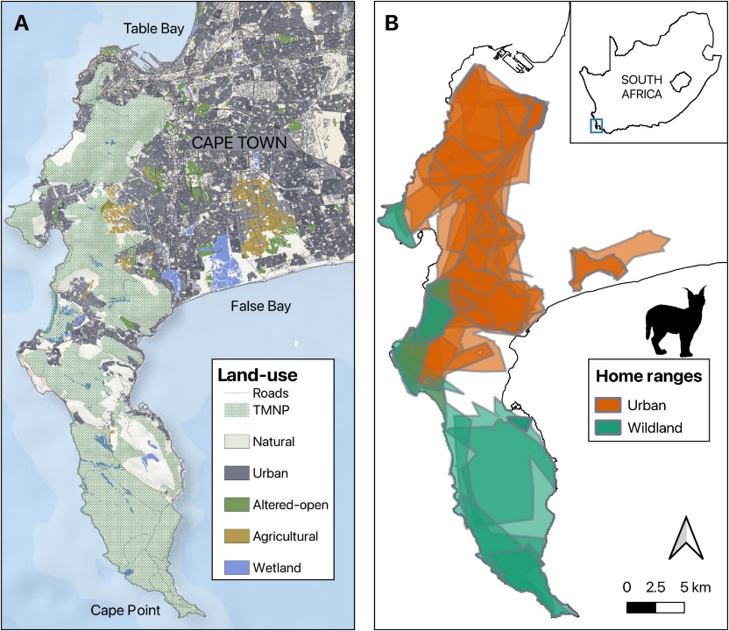

**FIGURE 1** Study area showing Table Mountain National Park, Cape Town, South Africa, including major land-use zones and the GPS-tracked home range of urban and wild caracals. (Adapted from “The Cat's Whiskers: Stable Isotopes Reveal Individual Specialisation of Adaptable Caracals (Caracal caracal) Foraging in an Urbanising Landscape,” by G. R. M. Leighton, A. R. Brooke, P. W. Froneman, L. E. K. Serieys, and J. M. Bishop, 2025, Ecology and Evolution, 15, e71154. Copyright 2025 by Ecology and Evolution.)

**2.2 Animal Capture and GPS Telemetry**

Data for Laduma (TMC01) were sourced from the Urban Caracal Project Movebank database (Serieys & Bishop, 2025). The adult male caracal (~3 years old, 31.1 kg) was captured on 19 November 2014 using a custom box trap baited with roadkill. Immobilization was achieved via ketamine hydrochloride (10 mg/kg) and medetomidine (0.08 mg/kg) intramuscular injection, following established procedures (Serieys & Bishop, 2025). Biological samples for genetic and toxicological analyses were collected, and a GPS-enabled VHF collar (e-obs GmbH, Munich) programmed to record locations every 2 hours was fitted. After recovery, Laduma was released at capture. Tracking spanned from 19 November 2014 to 31 May 2015, yielding 2,160 GPS locations over 162 days.

**2.3 Home Range and Core Area Estimation**

Home range and core use were estimated via kernel density estimation (KDE), a non-parametric method (Avenant & Nel, 2002; Ramesh et al., 2016). Analyses were conducted in R (version 4.x). The 95% KDE isopleth defined home range (95% of locations), and 50% isopleth identified core activity areas. A 90% KDE isopleth was also calculated for intermediate-intensity use. Resulting isopleth polygons were exported as shapefiles.

**2.4 Spatial and Temporal Analysis**

Spatial analysis used QGIS 3.x, integrating GPS data with spatial layers on park boundaries, land use, vegetation, fire perimeters, and urban settlements. Polygon shapefiles of the park and adjacent urban areas were refined using high-resolution satellite imagery (Google Earth Pro). All spatial outputs, including KDE isopleths and movement trajectories, were georeferenced and visualized accordingly.

# 3 Results

# 3.1 Home Range and Core Area Estimation

Kernel density estimation of GPS data from Laduma (TMC01) over 162 days (19 Nov 2014–31 May 2015) showed extensive space use across the Cape Peninsula. His total home range covered 173.8 km², from Signal Hill (north) to Silvermine Nature Reserve (south), spanning protected fynbos to suburban and agricultural areas (Figure 2). The 95% KDE isopleth covered 123.8 km², representing full movement including exploratory excursions. The 90% utilization area (97.3 km²) included intermediate use zones along the eastern park boundary extending into peripheral habitats. The 50% core area (19.96 km²) was concentrated in the northern Table Mountain region around Rhodes Memorial and Newlands Forest (Figure 3), comprising roughly 11.5% of the total range.

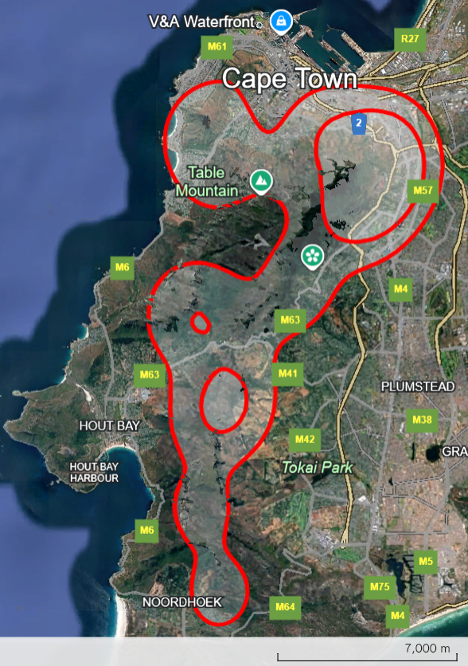

**FIGURE 2** Estimated home range (95% kernel density estimation) of the male caracal Laduma (TMC01) on the Cape Peninsula, derived from GPS tracking data collected between November 2014 and May 2015.

**3.2 Spatial Distribution and Habitat Clustering**

GPS locations showed clustering at Table Mountain National Park, Kirstenbosch Botanical Garden, Hout Bay, Constantia, and smaller reserves and agricultural areas (Figure 2 and 3). Approximately 70% of core area locations corresponded to rocky outcrops, dense vegetation, and stream valleys. The 50–90% isopleth included suburban edges and trail areas with intact vegetation corridors near protected zones. The 90–95% isopleth reflected exploratory movements into Constantia and nearby areas.

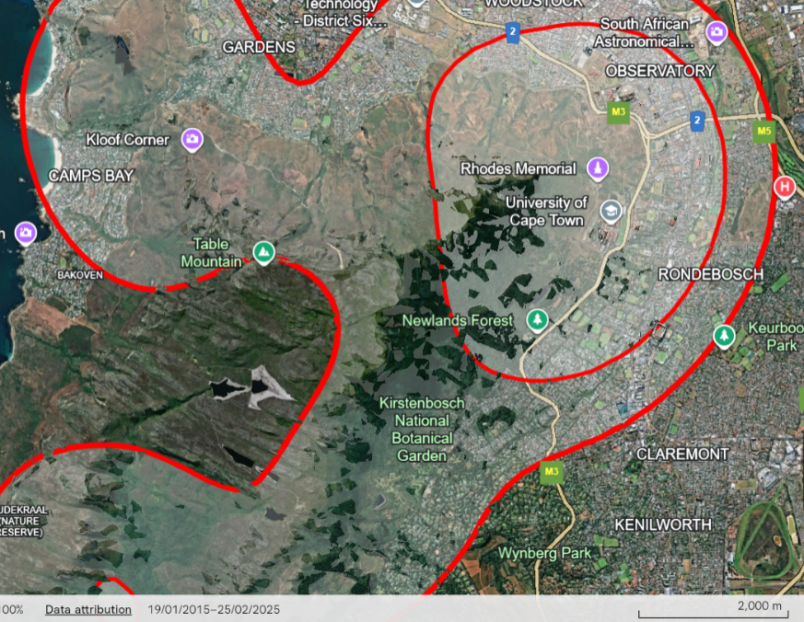

**FIGURE 3** Core use area (50% kernel density estimation) of Laduma within Table Mountain National Park, highlighting intensively used habitat patches around Rhodes Memorial and Newlands Forest.

**3.3 Temporal Movement Patterns**

Laduma exhibited cathemeral activity, with movements recorded throughout day and night (Figure 2). From November to January, movements were largely restricted to the northern core, with few excursions (Figure 4a). Movement intensity increased in February 2015, expanding southward into Constantia and adjacent minimally used regions.

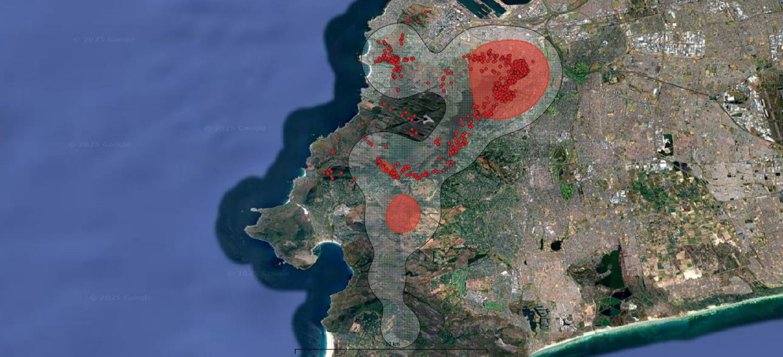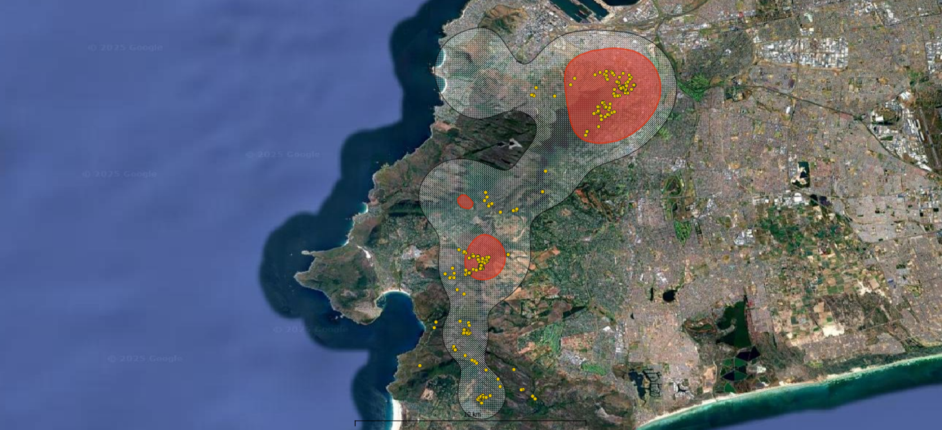

**b**

**a**

**FIGURE 4** Monthly movement trajectories of Laduma (TMC01): (a) overall movements across the study period (November 2014–May 2015) and (b) detailed movements during March 2015, encompassing the Cape Peninsula wildfire event.

**3.4 Fire-Responsive Movement**

In late February 2015, a week before the Cape Peninsula wildfire, Laduma shifted south into Constantia, beyond his regular core (Figure 4b). During and immediately after the fire (March–early April), he stayed in fire-affected areas and explored recently burned patches extending toward Noordhoek. By April, he returned to pre-fire core areas near Rhodes Memorial and Newlands Forest, resuming typical space use. This post-fire exploratory phase lasted three weeks.

**3.5 Spatial and Biogeographic Context**

Laduma’s range covered multiple biogeographic and land-use zones within and around Table Mountain National Park. The core area was primarily the northern highlands and valleys of the park. Intermediate use zones included recreational and suburban edges such as Kirstenbosch Botanical Garden and trail corridors, despite heavy human activity. Peripheral areas included agricultural lands, suburban interface zones, and fragmented habitat patches. The range was geographically constrained by the Atlantic Ocean (west), False Bay (east), and urban development (north), limiting dispersal beyond the peninsula.

**4 Discussion and Conclusions**

Laduma’s movement ecology reflects complex responses to natural disturbances and anthropogenic features typical of urban-edge carnivores (Serieys et al., 2023). His large home range (173.8 km²) exceeds those in protected areas (15–65 km²) and aligns with fragmented landscapes where territories overlap (Avenant et al., 2016; Ramesh et al., 2016; Teichman et al., 2023). Male caracals maintain extensive territories encompassing several female ranges, with home range size inversely related to prey density (Avenant & Nel, 2002). Laduma’s range size is expected for a reproductively active male confined by urbanization and ocean barriers (Kyriazis et al., 2024; Serieys et al., 2023).

**4.1 Habitat Selection and Movement Patterns**

Laduma showed strong fidelity to boundary areas of Table Mountain National Park, with a 50% core area (19.96 km²) around Rhodes Memorial and Newlands Forest (Serieys et al., 2023). This aligns with caracal preferences for rugged terrain and dense vegetation that support ambush hunting and shelter from humans (Davis et al., 2023; Ramesh et al., 2016). Whereas wildland caracals avoid urban edges, urban-edge individuals adopt risk-mitigation to persist (Serieys et al., 2023). Laduma’s proximity to suburbs was buffered by intact vegetation, enabling movement and hunting near protected edges (Leighton et al., 2023; Serieys et al., 2023). The diverse prey base in the fynbos ecosystem supports his persistence (Leighton, 2021). Caracals mainly feed on small mammals like rodents and rock hyrax, supplemented by birds and invertebrates (Braczkowski et al., 2012; Jansen et al., 2019; Melville et al., 2004). Despite high human recreation, Laduma’s cathemeral pattern suggests tolerance of predictable, non-threatening human presence, a common mesopredator trait in human-modified landscapes (Dobamo, 2019; Veals et al., 2020).

**4.2 Fire-Responsive Behaviour**

Laduma’s movement into Constantia a week before the March 2015 wildfire is noteworthy (Serieys et al., 2023). He remained in fire-affected areas during and after the event, exploring burned patches extending to Noordhoek before returning to his core range by April (Serieys et al., 2023). This pre- and post-fire movement may be adaptive foraging in fire-altered habitat where vegetation changes increase prey detectability (Leighton, 2021; Davis et al., 2023; Jooste, 2020; Steenkamp, 2018). Whether learned, olfactory, or seasonal remains unknown (Dobamo, 2019). Fire occurs every 10–15 years in fynbos, highlighting caracals’ ecological flexibility in disturbance-prone ecosystems (Leighton, 2021; Veals et al., 2020).

**4.3 Anthropogenic Threats and Mortality**

Despite adaptations, caracals face major anthropogenic risks (Serieys et al., 2023). Vehicle collisions account for 73% of deaths, including Laduma’s in 2017 (Serieys et al., 2023). Also, 94% are exposed to anticoagulant rodenticides, linked to poisoning and increased vulnerability (Leighton et al., 2023; Serieys et al., 2023). Rodenticides likely impair motor and anti-predator functions, raising mortality risk (Leighton et al., 2023). Habitat fragmentation, genetic isolation, and chronic stress reduce gene flow, increase inbreeding, and limit adaptability (Kyriazis et al., 2024). Urban-edge caracals show trophic downgrading and dietary specialization linked to resource competition and habitat degradation (Leighton et al., 2023; Leighton et al., 2025). Behavioral plasticity alone is insufficient for persistence amid urban pressures (Nattrass & O’Riain, 2020).

**4.5 Conclusions**

This study offers valuable insights into an apex mesocarnivore’s ecology in fragmented peri-urban landscapes (Serieys et al., 2023). Laduma’s large home range, protected area fidelity, cathemeral activity, and fire response illustrate ecological flexibility in human-altered environments (Dobamo, 2019; Veals et al., 2020). However, his death by vehicle collision underscores that behavioural adaptations alone can’t counterbalance anthropogenic threats. These findings support conservation strategies integrating movement ecology, threat mitigation, and habitat connectivity to sustain urban caracal populations worldwide (Nattrass & O’Riain, 2020; Serieys et al., 2023).

# References

Avenant, N., Drouilly, M., Power, R., Thorn, M., Martins, Q., Neils, A., Plessis, J., Do Linh San, E. (2016). A conservation assessment of *Caracal caracal*. [**https://doi.org/10.2305/IUCN.UK.2016-2.RLTS.T3847A50650230.en**](https://doi.org/10.2305/IUCN.UK.2016-2.RLTS.T3847A50650230.en)

Avenant, N., & Nel, J. (2002). Among habitat variation in prey availability and use by caracal *Felis caracal*. *Mammalian Biology*, 67, 18–33. [**https://doi.org/10.1078/1616-5047-00033**](https://doi.org/10.1078/1616-5047-00033)

Braczkowski, A., Watson, L., Coulson, D., Lucas, J., Peiser, B., Rossi, M. (2012). The diet of caracal, *Caracal caracal*, in two areas of the southern Cape, South Africa as determined by scat analysis. *South African Journal of Wildlife Research*, 42, 111–116. [**https://doi.org/10.3957/056.042.0206**](https://doi.org/10.3957/056.042.0206)

Davis, R. S., Gentle, L. K., Mgoola, W. O., Stone, E. L., Uzal, A., Yarnell, R. W. (2023). Habitat structure and the presence of large carnivores shape the site use of an understudied small carnivore: caracal ecology in a miombo woodland. *Mammal Research*, 68, 113–120. [**https://doi.org/10.1007/s13364-023-00668-6**](https://doi.org/10.1007/s13364-023-00668-6)

Dobamo, T. (2019). Ecology of caracals and their distribution in Africa: a review paper. *Ecology*, 9, 51–63. DOI: 10.7176/JBAH

Jansen, C., Leslie, A. J., Cristescu, B., Teichman, K. J., Martins, Q. (2019). Determining the diet of an African mesocarnivore, the caracal: scat or GPS cluster analysis? *Wildlife Biology*, 2019, 1–8. [**https://doi.org/10.2981/wlb.00595**](https://doi.org/10.2981/wlb.00595)

Jooste, E. C. (2020). Ecology and diet of the caracal (*Caracal caracal*) on lethal and non-lethal control farms in the Karoo. <https://hdl.handle.net/10566/16751>

Kyriazis, C. C., Serieys, L. E. K., Bishop, J. M., Drouilly, M., Viljoen, S., Wayne, R. K. (2024). The influence of gene flow on population viability in an isolated urban caracal population. *Molecular Ecology*, 33, e17346. [**https://doi.org/10.1111/mec.17346**](https://doi.org/10.1111/mec.17346)

Leighton, G. R. M., Brooke, A. R., Froneman, P. W., Serieys, L. E. K., Bishop, J. M. (2025). The Cat's Whiskers: Stable Isotopes Reveal Individual Specialisation of Adaptable Caracals (*Caracal caracal*) Foraging in an Urbanising Landscape. *Ecology and Evolution*, 15, e71154. [**https://doi.org/10.1002/ece3.71154**](https://doi.org/10.1002/ece3.71154)

Leighton, G. R., Froneman, W., Serieys, L. E., Bishop, J. M. (2023). Trophic downgrading of an adaptable carnivore in an urbanising landscape. *Scientific Reports*, 13, 21582. [**https://doi.org/10.1038/s41598-023-48490-w**](https://doi.org/10.1038/s41598-023-48490-w)

Leighton, G. R. M. (2021). Life on the edge: exploring the effects of urbanisation on the foraging ecology and ecotoxicology of caracals. <http://hdl.handle.net/11427/35894>

Melville, H. I. A. S., Bothma, J. du P., Mills, M. G. L. (2004). Prey selection by caracal in the Kgalagadi Transfrontier Park. *South African Journal of Wildlife Research*, 34, 67–75. <https://hdl.handle.net/10520/EJC117182>

Nattrass, N., & O’Riain, M. J. (2020). Contested natures: conflict over caracals and cats in Cape Town, South Africa. *Journal of Urban Ecology*, 6. [**https://doi.org/10.1093/jue/juaa019**](https://doi.org/10.1093/jue/juaa019)

Parchizadeh, J., Schooler, S. L., Adibi, M. A., Arias, M. G., Rezaei, S., Belant, J. L. (2023). A review of caracal and jungle cat diets across their geographical ranges during 1842-2021. *Ecology and Evolution*, 13, e10130. [**https://doi.org/10.1002/ece3.10130**](https://doi.org/10.1002/ece3.10130)

Ramesh, T., Kalle, R., Downs, C. T. (2016). Space use in a South African agriculture landscape by the caracal (*Caracal caracal*). *European Journal of Wildlife Research*, 63, 11. [**https://doi.org/10.1007/s10344-016-1022-4**](https://doi.org/10.1007/s10344-016-1022-4)

Serieys, L. E. K., Bishop, J. M. (2025). Data from: Study "Caracal movement ecology study in Cape Town, South Africa." Movebank data repository. [**https://doi.org/10.5441/001/1.qv1k35kj**](https://doi.org/10.5441/001/1.qv1k35kj)

Serieys, L. E. K., Bishop, J. M., Rogan, M. S., Smith, J. A., Suraci, J. P., O’Riain, M. J., Wilmers, C. C. (2023). Anthropogenic activities and age class mediate carnivore habitat selection in a human‐dominated landscape. *iScience*, 26, 107050. [**https://doi.org/10.1016/j.isci.2023.107050**](https://doi.org/10.1016/j.isci.2023.107050)

Steenkamp, E. (2018). Mesopredator abundances, prey interactions and diet of *Caracal caracal* and *Canis mesomelas* in the Gamkaberg, Western Cape. Stellenbosch University. <https://scholar.sun.ac.za/handle/10019.1/105098>

Teichman, K. J., Cristescu, B., Crevier, L., O'Riain, M. J., Hodges, K. E. (2023). Movement Choices of Persecuted Caracals on Farmlands in South Africa. *Rangeland Ecology & Management*, 88, 77-84. [**https://doi.org/10.1016/j.rama.2023.01.002**](https://doi.org/10.1016/j.rama.2023.01.002)

Veals, A. M., Burnett, A. D., Morandini, M., Drouilly, M., Koprowski, J. L. (2020). *Caracal caracal* (Carnivora: Felidae). *Mammalian Species*, 52, 71–85. [**https://doi.org/10.1093/mspecies/sey008**](https://doi.org/10.1093/mspecies/sey008)